

|  |  |
| --- | --- |
| OURSE NAME: | FINANCE & ACCOUNTING WITH ZOHO BOOKS |
| PROJECT TITLE: | FASHION HAVEN |
| PROJECT SUBMITTED TO: | SMART INTERNZ |
| YEAR: | 2023-2024 |
| DEPARTMENT: | COMMERCE |
| SEMESTER: | V |
| TEAM ID: | NM2023TMID10472 |
| MEMBERS OF THE GROUP: | |  |  | | --- | --- | | Register No | Student Name | | 1321151034 | S.SAHIRA(LEADER) | | 1321151035 | D.SRIDEVI | | 1321151036 | S.SUBALATHA | | 132151037 | P.SWETHA | |
| GUIDED BY: | Mrs. M. PRIYANKA, B.COM. M.COM (CA). M.PHIL. Assistant Professor  Ms.S.GOWSALYA B.COM(CA).,M.COM.,M.PHIL. Assistant Professor |
| SPOC NAME: | Ms. K. Elizabeth, M.Sc., M.Phil., B.Ed., Assistant Professor |

**INDEX**

|  |  |
| --- | --- |
| **CONTENT** | **PAGE NO** |
| **INTRODUCTION** | **3** |
| **PROBLEM DEFINITION & DESIGN THINKING** | **4-6** |
| **RESULT** | **7-8** |
| **ADVANTAGES AND DISADVANTAGES** | **9-11** |
| **APPLICATIONS** | **12** |
| **CONCLUSION** | **12** |
| **FUTURE SCOPE** | **12-13** |

**FASHION HAVEN**

**INTRODUCTION:**

* Fashion Haven Is Aonline Retail Store, Leverages Zoho Books To Manage Their Inventory And Track Sales. They Can Generate Invoices and Manage Customer Payments Seamlessly.
* Zoho Books Also Enables Them To Reconcile Bank Transactions And Genrate Financial Reports, Helping Them Make Informed Decision About Their Business.
* Fashion Haven Is A Private Limited Company Also Registered Under GST In Tamil Nadu. Fashion Haven Is A Retailor Of Various Lifestyle Products In Wholesale And Retail, It Has A Wide Range Of Customers All Over The State And It Procures From Various Suppliers In The State. It Operates At A Gross Profit Margin Of 50%.

**PREPARTION AND MAINTANENCE OF ZOHO BOOKS FOR FASHION HAVEN:**

\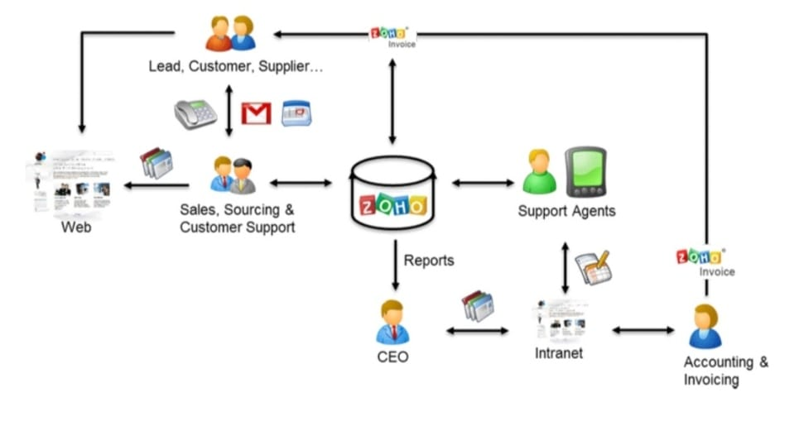

**OVERVIEW:**

* Fast fashion is the business model of replicating recent catwalk trends and high-fashion designs, mass-producing them at a low cost, and bringing them to retail stores quickly while demand is at its highest.
* Fast fashion is a design, manufacturing, and marketing method focused on rapidly producing high volumes of clothing.
* Fast fashion garment production leverages trend replication and low- quality materials (like synthetic fabrics) in order to bring inexpensive styles to the end consumer.

**PURPOSE:**

**1. BREAKS THE NORMS**

* As society grows and advances, attitudes develop, some of which can tear down years of austerity. Fashion, for example, adapts to changing gender dynamics. Dresses for men have become commonplace as people grow more comfortable with gender fluidity.

**2. INSPIRES CREATIVITY**

* Clothing is a method of self-expression that allows people to be their true selves. From custom-made garments to plain T-shirts, there is no end to how one can express oneself. New fabrics and applications develop daily, opening doors to new and better ideas.

**3. TELLS A STORY**

* Fashion not only serves a human need but by studying its evolution, we can mark gradual, important changes in society. Every era has a look that defines the most important details and sets the base for improvement and innovation.
* The history and evolution of men's suits is a clear example of how society managed to create elements that would have a big impact on future generations. The suits we wear today still recycle old ideas with modern twists.

**4. INCREASES SELF- CONFIDENCE**

* Many people struggle with this, but the right piece of clothing in the right situation can boost a person's mood and completely transform them.
* Clothes influence how we look at someone. They help create an idea of what we think about their personality. Wearing what makes you comfortable is a statement, and people will respect your individuality. This is an essential detail of why fashion is important.

**PROBLEM DEFINITION AND DESIGN THINKING:**

**EMPATHY MAP:**

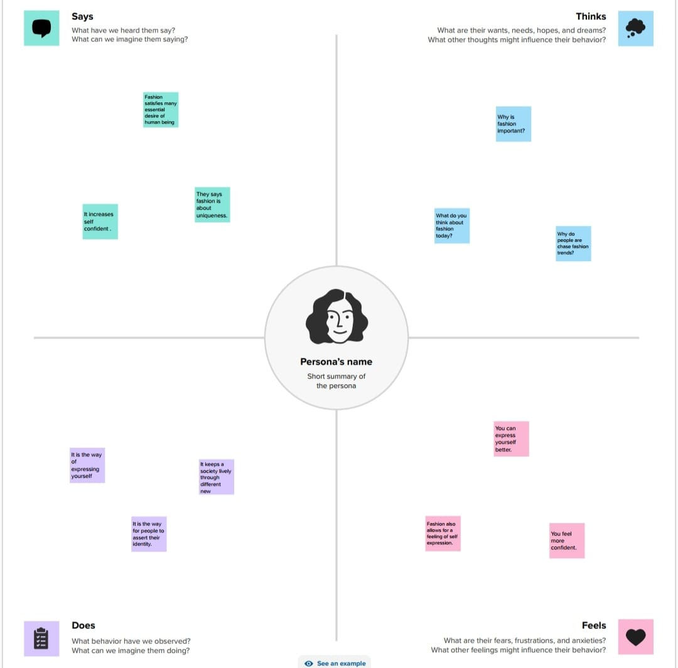

**BRAIN STROMING:**

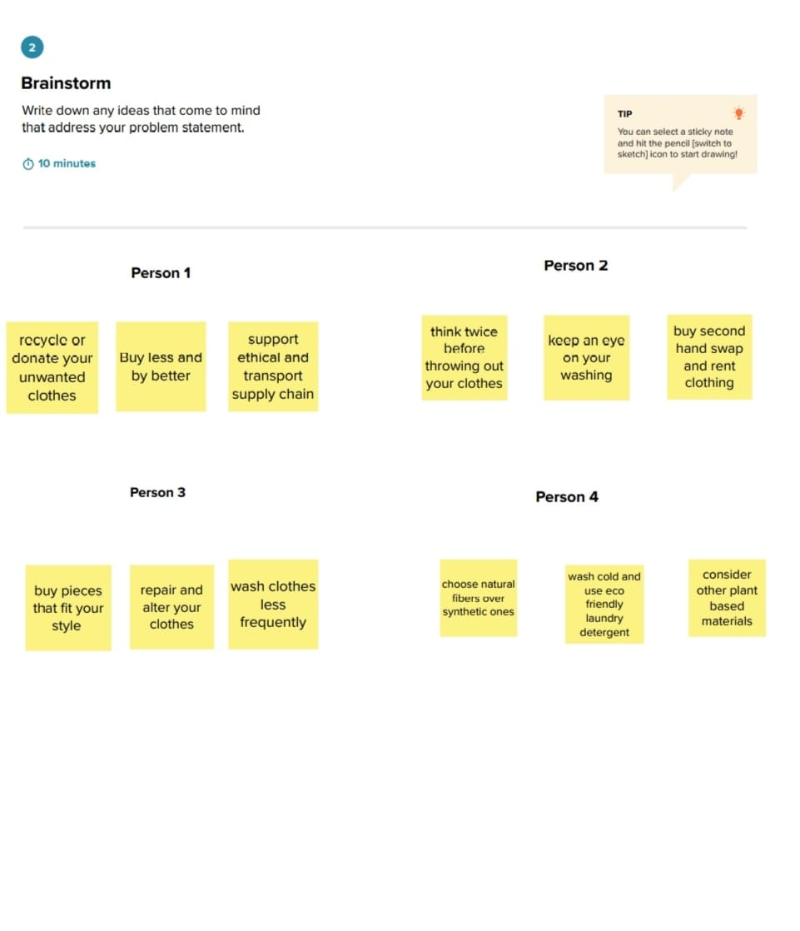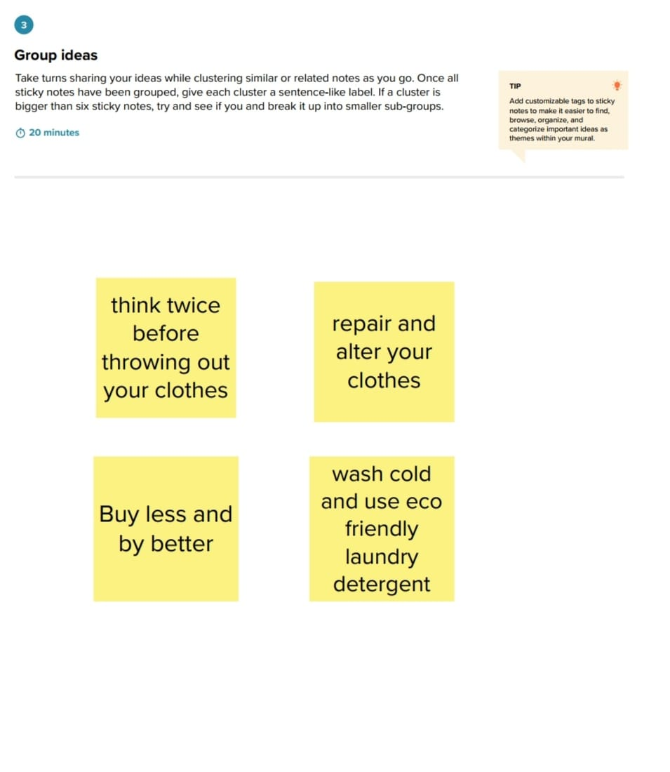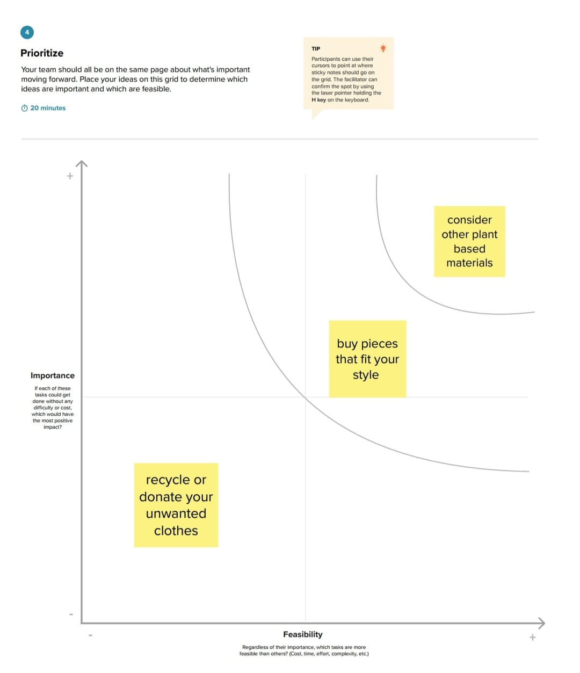

**RESULT:**

**PROFIT AND LOSS ACCOUNT:**

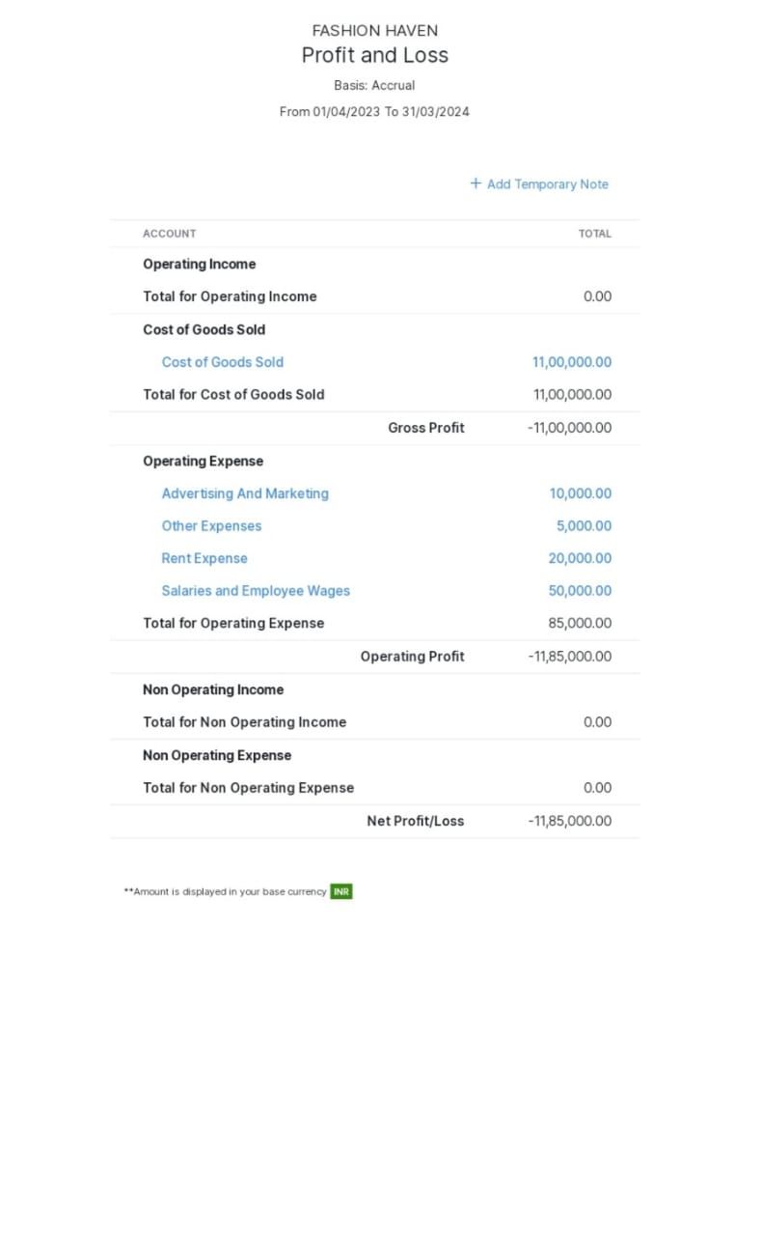

**BALANCE SHEET:**

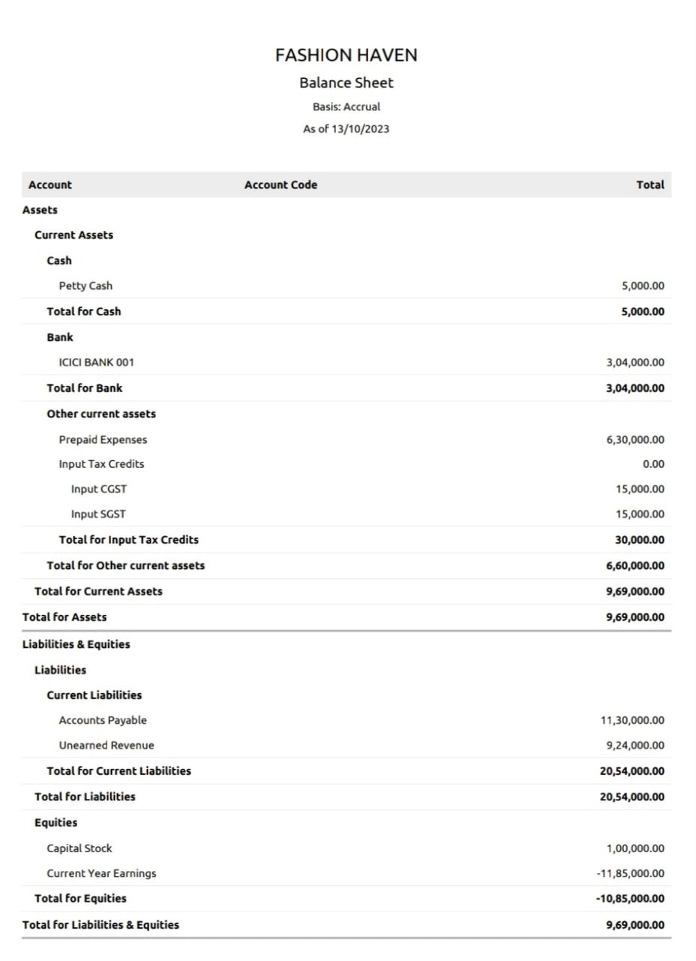

**ADVANTAGES:**

**1. Keep pace with Your Age:**

* This is an age of intense competition where everyone has to take part. Whatever liking or disliking you may be having, never forget to adopt the vogue of the day. Fashion is not limited to beautification or personal grooming;it encompasses whatever the majority of the people are doing around you that can be related to education, travelling or a particular way of behaving.
* For instance, you can say, "There is a fashion of learning English throughout the globe".

**2. An Inspiring Personality:**

* reoudate One of the greatest advantages of fashion is the development of your personality. The people, in your company, get impressed by you and follow you as a model.
* On the other hand, if your ways and manners ad, folks will neither like you nor enjoy your company.

**3. Beautification:**

* This is what people call the primary goal of fashion and limit the broader term to just one of its types, i.e. personal grooming.
* For humans, beauty is what attracts the most and becomes a piece of permanent joy as the Poet of Love (John Keats) said, "A thing of beauty is a joy forever".

**4. A Sign of Status:**

* Fashion is not just the name of putting successive layers of makeup on your face; it is a symbol of your status in the society as well.
* It is a thing of common observation that elite class excel in the field of fashion, and the lower class either do not give heed to it, or just restrict it to only some special occasions.

**5. It Makes You Stay Confident:**

* When you follow the prevailing trends in society, there is developed boldness in your personality while interacting with others. Fashionable people are usually outspoken and are a step ahead in the field of socialization.
* On the other hand, the lack of fashion makes s you timidand shy which is a dangerous thing as it suppresses your potential and snubs the power of initiative.

**6. Inner Delight:**

* When you become confident and do bold things in the society, you experience a sense of great inner delight. This is the fruit of your effort that you put in adopting and maintaining fashion.
* It also makes your mood fresh as you can see that the fashionable people always seem to be happy with a pleasant smile on their face.

**7. Fashion Brings Energy and Activity in Your Life:**

* Confidence, freshness and inner delight, which are the products of fashion, bring you out of the world of lethargy and make you active, fit and energetic. This is, perhaps, the best way to forget the pain and step into the world of pleasure and mesmerizing joy.

**DISADVANTAGES:**

1. **Expense:**

* Following fashion trends often requires frequent wardrobe updates, which can be costly and unsustainable for some individuals.

1. **Environmental Impact:**

* Fast-changing trends contribute to the "throwaway culture," leading to increased textile waste and environmental pollution.

**3.Pressure to Conform:**

* Fashion trends can create social pressure to conform, leading to a lack of individuality and self-expression.

**4.Body Image Concerns:**

* Some trends may not be inclusive of all body types, leading to body image issues and self-esteem issues.

**5.Ethical Concerns:**

* Many fashion trends are produced under exploitative labor conditions, raising ethical concerns about the industry's practices.
* Rebelle Theory appears to embrace the rebellious spirit, which can be empowering and liberating for those who value individuality.
* However, as a responsible consumer, it's essential to consider the potential drawbacks of following fashion trends.
* While the brand's focus on encouraging uniqueness is commendable, it's equally important to ensure that the production and sourcing practicesalign with ethical and sustainable standards.

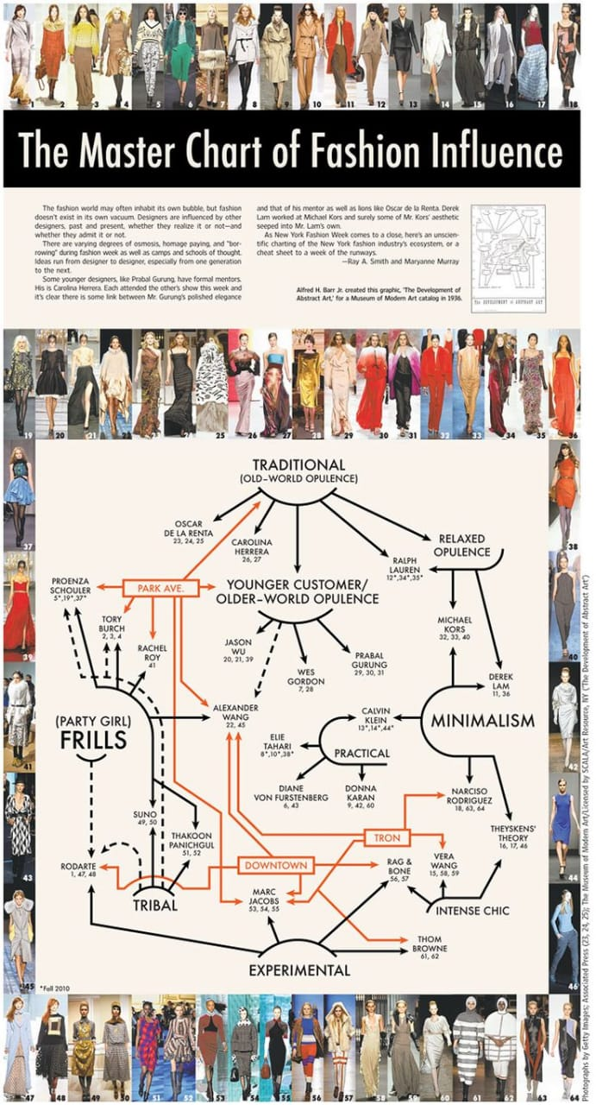

**APPLICATION:**

* Fashion forecasting can be used for many different reasons, the main reason being staying on top of current trends and knowing what your consumer is going to want in the future. This method helps fashion brands know what to expect and what to begin producing ahead of time.

**Forecasting has application in many situations:**

* Supply chain management and customer demand planning - Forecasting can be used in supply chain management to ensure that the right product is at the right place at the right time.

**CONCLUSION:**

* In conclusion, the fusion of fashion and technology has created exciting opportunities for innovation and creativity. With the use of new materials, 3D printing, wearable technology, and digital design tools, fashion designers can push the boundaries of what is possible and create unique and functional garments.
* Technology has also played a significant role in the fashion industry's sustainability efforts, allowing designers to create environmentally-friendly products and reduce waste. Additionally, advancements in e-commerce and digital marketing have made fashion more accessible to consumers worldwide reduce waste. Additionally, advancements in e-commerce and digital marketing have made fashion more accessible to consumers worldwide.
* As the fashion industry continues to evolve, the integration of technology will undoubtedly play a crucial role in shaping its future. By embracing these new technologies and finding ways to incorporate them into the design process, fashion designers can create a more innovative and sustainable industry that meets the needs of modern consumers.

**FUTURE SCOPE:**

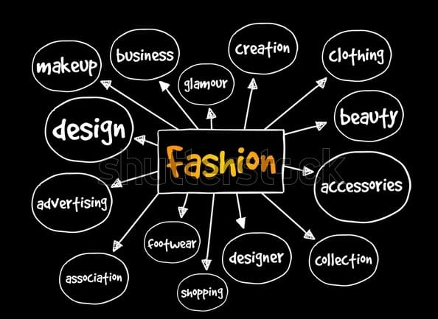

* The scope of Fashion Technology is broad and boundless. It includes the design, production, marketing and distribution of garments, footwear, leather goods, textiles and jewelry.
* According to a report, the Indian fashion market is expected to grow at a compound annual growth rate (CAGR) of 11-12% to reach $115-125 billion by 2025. However, with the increasing competition, changing consumer preferences, and technological disruptions, the industry is facing both opportunities and challenges.
* The scope of Fashion Designing isn't just restricted to the fashion world but is diverse and inclusive in nature thereby making the Fashion Industry highly competitive in nature. The below-mentioned sectors are where the Fashion Industry is highly in demand and blooming.